Content Types

Continuing Education (Courses / Webinars)

Landing Page View
The image below shows the actual node as a user would be redirected to it through the search or the block / list views above.
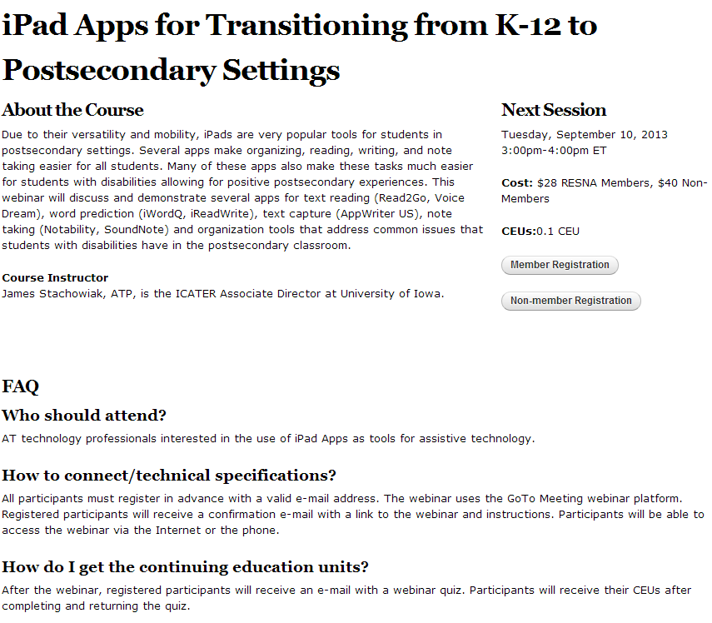
The page will start of with the main title, followed by the actual body (main content). On the right hand side, detailed information on the next session such as date, time, costs (member and non-member), CEUs, and registration links (member and non-member) will be displayed.
If a video is available, it will be displayed between the course instructor and the FAQs.
At the bottom of the page, FAQs will be displayed depending on which FAQ categories are matching as the FAQ categories will be shared between this content type and the the FAQ content type.

Publishing workflow

RSS feed

An RSS feed for this content type will be created. The latest 25 items are listed.

Navigation Flow, URL Structure and Menu Positions

The URL will for this content type will be created as follows:
professional-development/continuing-education/{category webinar or course}/title

Access / Permissions
Anonymous user can access the content.
Webmaster and above can edit / upload new content.

References to Wireframes
http://resna.newtarget.net/professional-development/webinars/ipad-apps-transitioning-k-12-postsecondary-settings

Other Notes
The content type is used in two different locations in the main menu and therefore two views need to be created to display either Webinar or Course. The views need to be placed under Professional Development -> Webinar and Professional Development -> Continuing Education -> Course

SIG / PSG

At a Glance
This content type is used for the Special Interest Groups (SIGs) and Professional Specialty Groups (PSGs).

Content Fields
The following attributes are available for this content type.
- Title [text field*]
- Category [select box {SIG, PSG}]
- Body [body field*]
- Officers (can be multiple)
  - Title [text field]
  - Name [text field]
  - Email [Email Field]
  - Phone Number [text field]
  - Show phone number [checkbox]
  - MemberSuite Reference [MemberSuite User ID]
- Weight

Block View
A block view simply listing the names will be created for each category [SIG and PSG].

List Views (Grid / List)
N/A.

Landing Page View
The following Layout will be used for this content type:

{Title}
{Officer 1 Title}: {Officer 1 Name}, {Officer 2 Email}*
{Officer 2 Title}: {Officer 2 Name}, {Officer 2 Email}, {Officer Phone Number (if show phone
number is checked}*

{Body}

*If the MemberSuite Reference is available, New Target will pull the information directly from the MemberSuite database. In addition an image to each person will be displayed if the image link is also available in MemberSuite. This way, the users are maintaining their records on their own. If a title changes in MemberSuite, the new title will automatically be pulled from MemberSuite onto the website.

Publishing workflow
Content editors can create the nodes of this content type, but are never able to publish the content. Editors will mark the content as ready to review through which an email will be triggered to the webmaster. The webmaster (administrator) can publish the content or decline the publication with a comment. The webmaster and administrator can always by-pass the publishing workflow.

RSS feed
Not part of any RSS feed.

Navigation Flow, URL Structure and Menu Positions
The pages will live under the following hierarchy:
About → Bylaws → Leadership → Committee → Special Interest Groups
About → Bylaws → Leadership → Committee → Professional Specialty Groups

Depending on the category (SIG or PSG), the content will be pulled on the different section of website.

Access / Permissions
Anonymous user can access the content.
Webmaster and above can edit / upload new slides.

References to Wireframes
N/A.

Other Notes
N/A.

Committee

At a Glance
This content type is used for the different committees.

Content Fields
The following attributes are available for this content type.
- Title [text field*]
- Body [body field*]
- Image [image upload]
- Next Meeting [full text field]
- Officers (can be multiple)
  - Title [text field]
  - Name [text field]
  - Employer [text field]
  - Email [Email Field]
  - Phone Number [text field]
  - Show phone number [checkbox]
- Work Program [full text field]
- ISO Related Activities [full text field]
- Membership information [multi file upload and file description]
- Related Standards [multiple; node reference]
- Category [Committee Type vocabulary]
- Weight

Block View
N/A.

List Views (Grid / List)
- Professional Standards Board & Board of Directors landing pages → MemberSuite
A list view will be created from this content type. It will list all items ordered by the weight. The following Layout will be used for each node in the list view:

{Title}
{Summary}
{Link to node}

Landing Page View
The following Layout will be used for this content type:

{Title}
{File Description}
Officers:
{Officer Title}: {Officer Name}
{Officer Employer}
{Officer Email}
{Officer Phone Number (if show phone number is checked)}
Next Meeting:
{Next Meeting}

{Body}

Work Program:
{Work Program}

ISO Related Activities
{ISO Related Activities}

AT Journal
In order to link to the AT Journal, a simple TPS Link can be created. The following code can be utilized for this.
<?
$ticketurl='http://www.tandfonline.com/loi/uaty20#.UjiibT-QH3E’;
if (($fp = fopen($ticketurl, 'r')))
{
$content = fread($fp, 1000000);
header("Location:".$content);
}
fclose($fp);
?>

The code has to be executed on the server level. Taylor & Francis Online needs to be contacted to inform them about the IP.
The code will only be triggered for members. If it is a non-member, the user will simply be redirected to Taylor & Francis Online and will only be able to view the freely available content.

